**FICHA APLICATIVA N°1**

|  |  |  |  |  |
| --- | --- | --- | --- | --- |
| **NOMBRES Y APELLIDOS** |  | | | |
| **CARRERA /SECCIÓN** |  | **DOCENTE** | **Carla Bengolea B.** | |
| **CURSO** | **Comunicación I** | **CICLO** | **I** | **Fecha:** |

1. **Visualiza las siguientes imágenes he infiere que significan**:



______________________________________________________________________________________________________________________________________________________________________________________________________________________________________________________________________________________________________

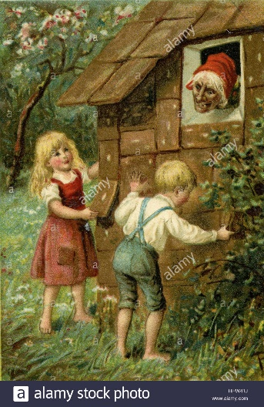

_______________________________________________________________________________________________________________________________________________________________________________________________________________________________________________________________________________________________________________________________________________________________________________________________________



______________________________________________________________________________________________________________________________________________________________________________________________________________________________________________________________________________________________________

1. **Infiera el significado de las siguientes palabras:**

* **Torre: _____________________________________________________________**
* **Perro: ______________________________________________________________**
* **Espada: ____________________________________________________________**
* **Cisne: ______________________________________________________________**
* **Llave: ______________________________________________________________**
* **Blanco: _____________________________________________________________**
* **Reloj: ______________________________________________________________**
* **Sol: ________________________________________________________________**
* **Lentes: ____________________________________________________________**
* **Empresa:___________________________________________________________**